TASK 03: HR Analytics Dashboard using Power BI
Intern Name: Ajitdada Gajanan Gharge
Internship: Data Analyst Intern
Organization: SkillCraft Technology
Task: Task 03 – HR Analytics Dashboard using Power BI
Tool Used: Microsoft Power BI Desktop, Power Query, DAX
Dataset Used: IBM HR Analytics Employee Attrition & Performance Dataset (WA_Fn-UseC_-HR-Employee-Attrition)

HR Analytics Dashboard using Microsoft Power BI
Objective
The objective of this task was to learn the basics of Microsoft Power BI and build an interactive HR Analytics Dashboard using the IBM HR Employee Attrition dataset. The dashboard was designed to analyze employee attrition based on different factors such as department, job role, gender, and age group. The main goal was to transform raw HR data into meaningful visual insights that help organizations understand employee turnover and support better decision-making.

Introduction
This was my first hands-on project using Microsoft Power BI. Initially, I had no prior experience with the Power BI interface, dashboard creation, or DAX formulas. Throughout this task, I learned how to import datasets, clean and transform data, create visualizations, build KPI cards, and design an interactive dashboard.
The project helped me understand how Business Intelligence (BI) tools are used to convert raw organizational data into easy-to-understand reports and dashboards. By the end of this task, I was able to create a complete HR Analytics Dashboard with multiple charts, KPI cards, and interactive filters.

Steps Performed
Step 1: Understanding the Dataset
The first step was to understand the HR Analytics dataset. The dataset contained employee-related information such as Employee Number, Age, Department, Job Role, Gender, Monthly Income, Attrition Status, Education, Business Travel, and other HR attributes.
Before creating any visualizations, I explored the dataset to understand the meaning of each column and identify which fields would be useful for analysis.

Step 2: Importing Data into Power BI
I imported the HR employee dataset into Microsoft Power BI Desktop. After loading the data successfully, I verified that all columns were imported correctly and that the data types were properly assigned.

Step 3: Data Cleaning
After importing the dataset, I checked for missing values and duplicate records. I verified that the dataset was clean and suitable for visualization. Since the data was already well-structured, only minimal preprocessing was required.
I also ensured that numerical and categorical fields had the correct data types before proceeding with dashboard creation.

Step 4: Creating Visualizations
The next step was to create meaningful visualizations.
I developed charts showing:
- Employee Attrition Overview
- Employee Count by Department
- Employee Count by Job Role
Initially, I mistakenly used the Sum of Employee Number instead of the Count of Employee Number, which produced incorrect results. After understanding the difference between aggregation methods, I corrected the visuals by changing the aggregation to Count/Distinct Count. This helped me understand how important correct aggregation is in Business Intelligence.

Step 5: Creating KPI Cards
To make the dashboard more informative, I created KPI cards showing:
- Total Employees
- Average Age
- Average Monthly Income
At first, I accidentally displayed the Sum of Monthly Income instead of the Average Monthly Income. After identifying the issue, I changed the aggregation to Average, resulting in a more meaningful KPI.
These KPI cards provide a quick summary of the organization's workforce without requiring users to analyze detailed charts.

Step 6: Creating Age Group Using DAX
One of the most important learning experiences in this project was creating a calculated column using DAX.
Since the dataset did not contain an Age Group column, I created one using a DAX formula that classified employees into four groups:
- 18–30
- 31–40
- 41–50
- 51+
This was my first experience writing DAX expressions. Initially, I was unfamiliar with the syntax, but after learning how the SWITCH() function works, I successfully created the calculated column.

Step 7: Adding Interactive Slicers
To make the dashboard interactive, I added slicers for:
- Department
- Gender
- Age Group
These slicers allow users to dynamically filter all visualizations on the dashboard. This significantly improved the usability of the dashboard and demonstrated one of Power BI's strongest features.

Step 8: Dashboard Formatting
Finally, I arranged all charts, KPI cards, and slicers into a professional dashboard layout. I added a dashboard title, resized the visuals for better readability, and aligned all components neatly to create a clean and organized appearance.
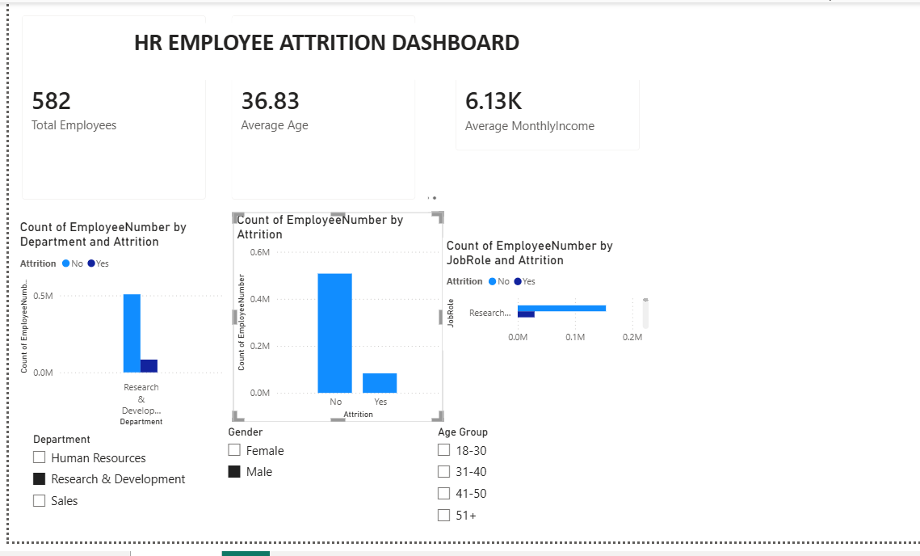

Challenges Faced
During this task, I encountered several challenges because I was completely new to Power BI.
Initially, I struggled to locate different visualizations and understand where fields should be placed for creating charts. I also found it difficult to understand the difference between categorical and numerical fields.
Another challenge occurred while creating KPI cards. I mistakenly used Sum instead of Count and Average for some measures, which resulted in incorrect values. After correcting the aggregation methods, the KPIs displayed accurate information.
Creating the Age Group column using DAX was another challenge because I had never written DAX formulas before. After learning the syntax and understanding how calculated columns work, I successfully implemented the required formula.
These challenges helped me improve my understanding of Power BI and gave me practical experience in troubleshooting dashboard issues.
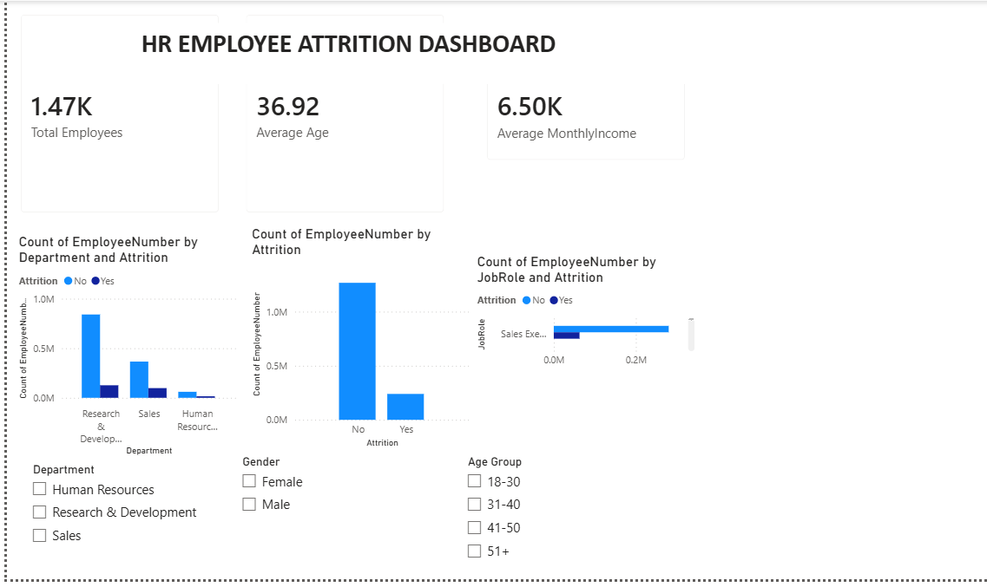

Learning Outcomes
This task significantly improved my understanding of Microsoft Power BI and Business Intelligence concepts.
Through this project, I learned:
- Importing datasets into Power BI.
- Performing basic data cleaning and validation.
- Creating bar charts and KPI cards.
- Using DAX to create calculated columns.

Conclusion
This project successfully demonstrated how Microsoft Power BI can transform raw HR employee data into meaningful business insights through interactive dashboards. By completing this task, I gained practical experience in data preparation, visualization, KPI creation, DAX calculations, and dashboard design.
Although I faced several challenges while learning Power BI for the first time, each problem helped me improve my understanding of the software. Successfully completing this dashboard has increased my confidence in using Business Intelligence tools and prepared me for more advanced analytics projects in the future.

